Description of “doc_brainstorm”:

Miscellaneous notes and concepts from our initial in-class brainstorm sessions (December 3rd and December 5th). Shows the process through which we decided on our final project, as well as an overview of each person’s proposed role in the project.

Ideas for concept

HI LENNON

1. Alien Fast food (Lennon)
   1. Alien dollars
   2. Mooncakes, astronaut ice cream
   3. Alien cars
2. Alien Dating Sim (Pearl)
   1. 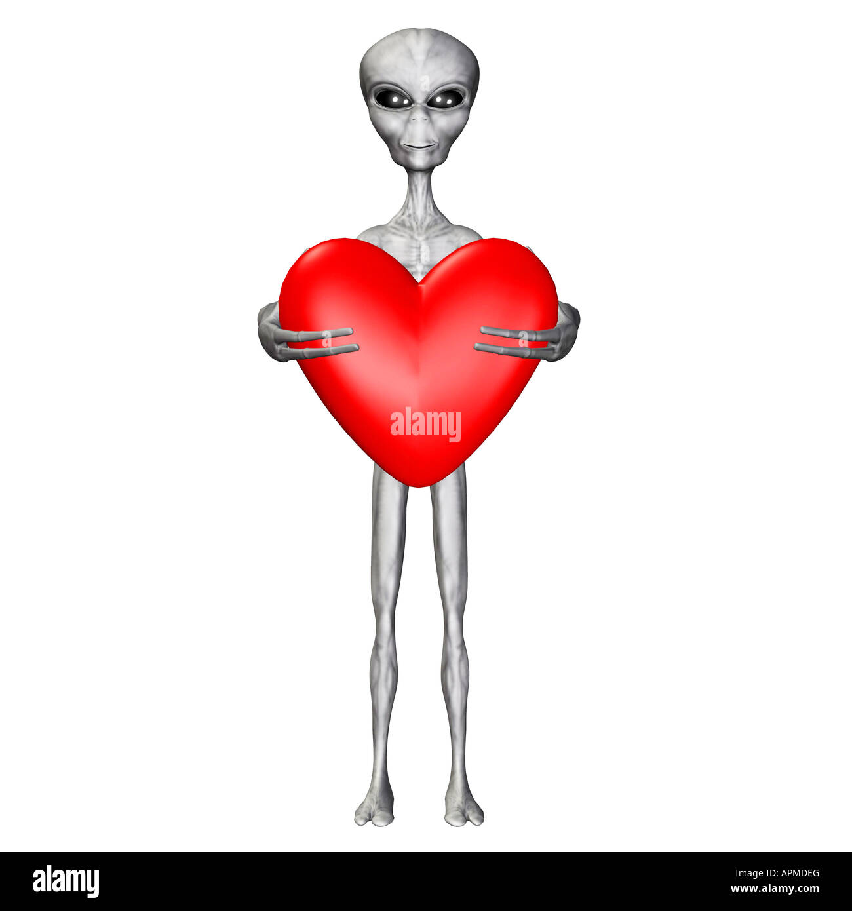
3. Alien clothing store (Ella)
   1. Online shopping
   2. Different genres of clothing
   3. Buy: Alien helmet, color contacts, glitter
   4. Clothing store but exclusive to aliens (no normal clothes)
      1. how is this even clothing??? - human observer
4. Build your dream life (Blessing :3)
   1. Adding dream house
      1. cottagecore
      2. beach view
      3. snowy mountain
   2. Dream car
   3. Mix the aesthetics
   4. Calculate prices (API?)
      1. how many minimum wage hours to get this life
5. All of our powers combined (🌟)
   1. Pick your planet
      1. Earth (but there ARE aliens)
      2. Mars (the aliens are like moss and kelp)
      3. Pluto (the aliens are political)
      4. Uranus (diamond ring
6. Date the planets (???)
   1. Each planet has alien
7. Pick your dream life
   1. Preparation phase
      1. checks for certain things before’

Earth is going to be exploded next week and you need to start your dream life in

* List for each planet
  + First item: planet
  + House
  + Partner
* List of everything that qualifies for that planet
* If statements checks for placement on list
* If you chose right house, check for that

NOTE!!!

* December 13 Blessing CANNOT WORK

Initial Roles:

Pearl:

* Concept, Media/Assets,
* Systems Management (overlooking GitHub/Comments/Commits)

Blessing:

* User Experience
* Frontend Development (Windows Forms)
* Programming Pioneer

Lennon:

* Worker Peasant (by Request)
* Will make main tree node system and perhaps the array for planets/ aliens

Presley:

* Worker Peasant (by Mandate)
* Heathcliff

Ella:

* Worker Peasant (by Mandate)

____________________________________________________________________________

NOTES:

* Main data structures to be used: Arrays and tree nodes!
* 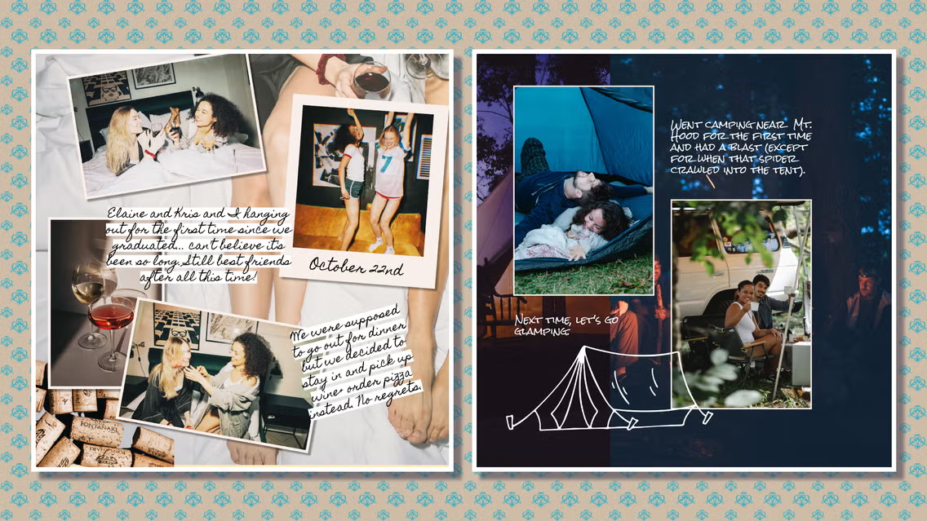

UI Inspiration: Scrapbook!